**Customer Segmentation Using Data Science Project Design**

|  |  |
| --- | --- |
| **Date** | **10-10-2023** |
| **Team ID** | **3884** |
| **Project Name** | **Age Based Customer Segmentation using Data Science** |

**Table of Contents**

|  |  |
| --- | --- |
| 1 | Introduction |
| 2 | Problem Statement |
| 3 | Design and Innovation Strategies |
| 3.1 | Data Collection and Feature Engineering |
| 3.2 | Data Pre-processing |
| 3.3 | Model Selection and Training |
| 3.4 | Geographic Analysis |
| 3.5 | Market Sentiment Analysis |
| 3.6 | Continuous Learning |
| 4 | Conclusion |

**1. Introduction**

Age-based customer segmentation is a fundamental practice in data science and marketing that involves dividing a customer base into distinct groups or segments based on their age. This segmentation strategy is valuable because age is often a significant factor influencing consumer behaviour, preferences, and purchasing patterns. By categorizing customers by age, businesses can tailor their marketing efforts, product offerings, and customer experiences to better meet the unique needs and expectations of each age group.

**2. Problem Statement**

A retail company wants to improve its marketing and product targeting strategies by understanding its customer base better. One crucial aspect of customer segmentation is age-based categorization, as different age groups often have distinct preferences, purchasing behaviours, and communication preferences. The company aims to use data science techniques to segment its customers into meaningful age groups.

**3. Design Strategies**

**3.1. Data Collection and Feature Engineering**

Data Collection and Feature Engineering for AGE based Customer Segmentation:

Age-based customer segmentation is a valuable approach for tailoring marketing strategies and product offerings. Here's a high-level overview of data collection and feature engineering for this task:

**1.Data Collection**:

Gather relevant customer data from various sources, such as CRM systems, online forms, or surveys. This data should include customer age, along with other demographic and be information.

**2.Feature Engineering:**

Create meaningful features that can help in segmentation. Some ideas include:

- Age Groups: Group the customers age to make the analysis more manageable.

- Age Range: Calculate the age range (difference between maximum and minimum ages) within a customer segment.

- Age-Centric Metrics: Compute statistics like mean, median, and standard deviation of ages within each segment.

**3.2. Data Pre-processing**

* Clean the data to handle missing values, outliers, and inconsistencies.
* Normalize or scale numerical features as needed.
* Convert categorical variables (e.g., gender) into numerical representations, such as one-hot encoding or label encoding.
* Ensure data privacy and compliance with regulations like GDPR.

**3.3. Model Selection and Training**

1. **Model Selection**:
   * Choose appropriate machine learning or clustering algorithms for segmentation.
   * Common choices include K-means clustering, hierarchical clustering, or decision trees.
2. **Model Training**:
   * Train the selected model using the preprocessed data.
   * Consider using techniques like cross-validation to ensure the model's robustness.

**3.4. Geographic Analysis**

Age-based customer segmentation is a powerful strategy. By analysing geographic data, you can tailor marketing efforts to specific age groups in different locations. This ensures a more personalized approach that resonates with the demographics of each area. Utilizing data science techniques allows for precise targeting and effective allocation of resources.

**3.5. Market Sentiment Analysis**

Incorporate sentiment analysis of market news, social media data, and online forums to gauge market sentiment.

Develop a sentiment score that quantifies market sentiment trends and integrates it as an additional feature in the prediction.

**3.6. Continuous Learning**

Continuous learning for incorporating dimensionality reduction techniques like PCA or t-SNE to visualize high-dimensional customer data and discover underlying patterns involves an iterative process to improve your data visualization and pattern discovery capabilities.

Continuous learning in dimensionality reduction and data visualization ensures that your approach remains effective and adapts to changing data and business requirements. It enables you to uncover valuable insights from high-dimensional data that can drive better decision-making and strategy development.

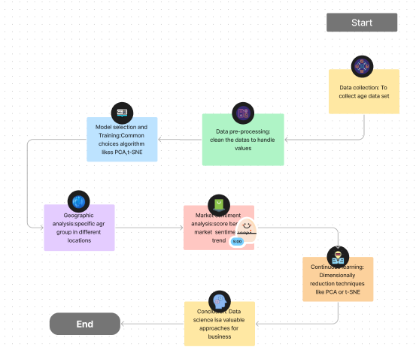

**4.Conclusion:**

In conclusion, age-based customer segmentation using data science is a valuable approach for businesses seeking to enhance their marketing strategies, improve customer engagement, and drive business growth. However, it's essential to approach this process with sensitivity to customer privacy and ethical considerations while continually refining and optimizing segmentation models to adapt to changing customer behaviours and preferences.

Top of Form